Sso response plan

  - For the
  - Permittee Name
Facility Name
NPDES Permit No. AL00XXXXX

Facility Address
City, Alabama Zip Code

Date Authored:

 | Date  Revised/Reviewed | Reviser/Reviewer  Signature and Title | Responsible Official  Signature and Title
□ Revision
□ Review
□ Revision
□ Review
□ Revision
□ Review
□ Revision
□ Review
□ Revision
□ Review
□ Revision
□ Review
□ Revision
□ Review
□ Revision
□ Review

Disclaimer of Endorsement:
This Template may be used by Permittees in developing their own SSO Response Plans. Use of the template by itself does not constitute compliance with any permit or relieve an operator of its responsibility to comply with all applicable federal, state, and local laws, regulations and/or applicable permits, and does not constitute a waiver or supersede the terms and conditions of any federal or state requirements or regulations and/or applicable permits regarding the operation and maintenance of a wastewater collection of conveyance system. This template should not be relied upon to identify regulatory requirements. The Permittee is solely responsible for ensuring that it takes the steps necessary to ensure compliance with all applicable requirements of federal, state and local laws and/or applicable permits. The suggestions herein should not be construed to constitute EPA or State approval of any method or specific equipment or technology installed or utilized by a collection system.

Table of Contents
Administrative Procedures 1
General Utility Information 2
Responsibility Information 3
Contact List 3
Responsibility Descriptions 4
Important Contact Information 5
Contact List 5
SSO and Surface Water Assessment 7
Probable SSO Event Location Table 7
General Collection System Area Map 8
Surface Waterbodies Identification Table 9
Response to Notification of Spills 10
Public Observation of an SSO 10
SCADA Alarms 10
Staff Observation of an SSO 11
Notification and Response 12
SSO Response Procedures 13
Customer Relations 13
Responder Priorities 14
Safety 14
Initial Response 14
Restore Flow 15
Contain the Spill 15
SSO Public Notification and Restricted Public Access 16
Recovery and Clean Up 17
Recovery of Spilled Sewage 17
Clean Up and Disinfection 17
Water Quality Sampling Procedures 18
Estimate the Volume of Spilled Sewage 19
Follow Up Activities 19
Claims for Backups into a Building 19
Public and County Health Department Notification 20
County Health Department Notification Requirements 20
Public Notification Requirements 20
Point of Contact 21
SSO Documentation and Reporting 22
Internal SSO Documentation 22
External SSO Documentation 22
Equipment Inventory 24
Appendix A 25
Example Warning Signs 25
Appendix B 28
Checklist for Plugged Sewer Line and Overflow Form 28
Appendix C 34
Methods for Estimating Spill Volume 35
Method 1 Eyeball Estimate 35
Method 2 Area/Volume Calculations 35
Method 3 Duration and Flowrate 36

Administrative Procedures
The SSO Response Plan shall be kept at the permittee facility/alternate location approved by the Department in writing. Training for any personnel required to implement the SSO Response Plan shall be provided by Permittee Name. Should significant revisions be made to the SSO Response Plan, training regarding the revisions shall be conducted as soon as possible. All training dates and locations shall be recorded below.
(Attach additional sheets if necessary)
Training Date | Training Location | Description
August 1, 2018 | Anytown WWTP | Training for SSO RP revisions for all staff

General Utility Information
Approximate Population of City / Town:
Approximate Number of Customers Served:
Estimated number of Linear Feet of Sanitary Sewer Pipe in System:
Number of Pump / Lift Stations in the System:
(List lift stations in this table. Attach additional sheets if necessary)
LS ID | LS Name | LS Address | Latitude | Longitude
(example) LS1 | Old Faithful | 555 Low Street | 36.555555 | -86.555555

If applicable, identify any subbasins designated by the Permittee below (attach maps if necessary):
Subbasin ID | Subbasin Name | HUC 8 Code
(example) SB1 | Water Creek | 55555555

Responsibility Information

Contact List
Title | Name | Primary Phone | Alternate Phone | Email
(example)
Primary SSO Coordinator
Secondary SSO Coordinator
Primary SSO Responder
Secondary SSO Responder
Responsible Official (Mayor / Chairman)
Other
Other
Other
Other
Other
Other
Other
Other
Other
Other
Other
Other

Responsibility Descriptions

John Smith, Primary SSO Coordinator and Utilities Chairman
Responsible for determinations concerning who to contact during an SSO to coordinate the response. Also responsible for assessing the SSO and initiating a series of response actions based on the type, severity, and destination of the SSO. Responsible for management and decision making for the sewer collection system. Lead manager during SSO events. Etc…
John Doe, Secondary SSO Coordinator and Utilities Chairman
In the absence of the Primary SSO Coordinator, the Secondary SSO Coordinator is responsible for the Primary SSO Coordinator duties.
Jason Smith, Primary SSO Responder
Responsible for providing notification to ADEM, the public, the county health department, and other affected entities such as public water systems. Also responsible for organizing crews for response and addressing public inquiries. Etc…
John Doe, Secondary SSO Responder
In the absence of the Primary SSO Responder, the Secondary SSO Coordinator is responsible for the Primary SSO Responder duties.
Others as necessary to clarify duties during an event…

Important Contact Information

Contact List
Title | Name | Primary Phone | Alternate Phone | Email
(example)
Local County Health Dept.
ADEM Engineer
ADEM SSO Hotline / eSSO* Web Address
Fire Chief
Police Chief
Medical
Newspaper
Radio Station
TV Station
Other
Other
Other
Other
Other
Other
Other
Other
* eSSO Hotline is being phased out and being replaced by the Electronic SSO Reporting System. Both notifications should not be made unless specifically identified in the NPDES Permit.
5

SSO and Surface Water Assessment

Probable SSO Event Location Table
(Use historic data, best professional judgement, etc. to identify probable SSO Event locations and list them here. Attach additional pages if necessary.)
Location ID / Name | Address | Latitude | Longitude | Evaluation Notes
(example)  LS1 / Old Faithful | 555 Low Street | 36.555555 | -86.555555 | Old Faithful lift station is located in a remote area that frequently loses power for days at the time and has a history of SSO events during stormy weather.

General Collection System Area Map
Includes surface waterbodies and the locations of public drinking water source(s). Mapping of all collection system piping, pump stations, etc. should be included if the information is already available. Any Swimming (http://gis.adem.alabama.gov/ADEM_Dash/use_class/index.html) or locally known recreational waterbodies should be specifically identified on the map.
(Insert or attach a map of the collection system.)

Surface Waterbodies Identification Table
Bodies in the table below are either classified as ‘Swimming’ by the State or not classified as ‘Swimming’ by the State (ADEM Admin. Code 335-6-11-.02), but rather known locally as a place where swimming or recreation typically occurs. Attach additional pages if necessary.
Classification | Location ID / Name | From | To
(example)  Swimming/Fish & Wildlife | Alabama River | Clairborne Lock and Dam | Alabama and Gulf Coast Railway
(example)  Locally Identified as Recreational | Fun River | Good Times Creek | Better Times Lake

Response to Notification of Spills
The Permittee Name has adopted service call/overflow response procedures requiring immediate response to minimize or eliminate an overflow.
When a notification of an SSO is received, it should be clearly communicated to the caller who will respond, the estimated time of arrival, and what areas will need to be accessed. The information provided by the caller should be verified before dispatching a field crew.

Public Observation of an SSO
Public observation is typically the most common way that a Utility is notified of blockages and spills. Contact information for reporting sewer spills and backups are as follows:
Website: https://www.anytown.com
Primary Telephone Number: (555) 555-5555
After Normal Working Hours Telephone Number: (555) 555-5555
Emergency Telephone Number: (555) 555-5555
Information Required from the Public
At a minimum, the date and time of observation and location of the SSO should be obtained from the public along with their contact information, if possible.

Normal Working Hours
The regular working hours for Permittee Name employees are Monday through Friday from 6:30 a.m. to 3:00 p.m., except holidays. When a report of a sewer spill or backup is made, Permittee Name staff route the call directly to the SSO Coordinator, who records the information required from the public, and initiates the response actions. The SSO Coordinator communicates the information to the SSO Responder. If the Primary SSO Coordinator/Responder is not available, the Secondary SSO Coordinator/Responder will fulfil the role of the Primary SSO Coordinator/Responder.

After Normal Working Hours
After working hours, calls are automatically routed to the Permitee Name After Hours Contact who records the information required from the public and then notifies the SSO Coordinator, who initiates the response actions. The SSO Coordinator communicates the information to the SSO Responder. If the Primary SSO Coordinator/Responder is not available, the Secondary SSO Coordinator/Responder will fulfil the role of the Primary SSO Coordinator/Responder. The Permittee Name Emergency dispatcher can be reached at 911 in emergency situations.

SCADA Alarms
If SCADA is available, add SCADA alarm response information here.

Staff Observation of an SSO
Field crews and contractors perform periodic work on its sewer system facilities. Any SSOs noted within the sewer system facilities are to be reported immediately to the SSO Coordinator.

Notification and Response
(INSERT YOUR OWN LIST OR FLOW CHART OR DRAWING HERE)
EXAMPLE FLOWCHART
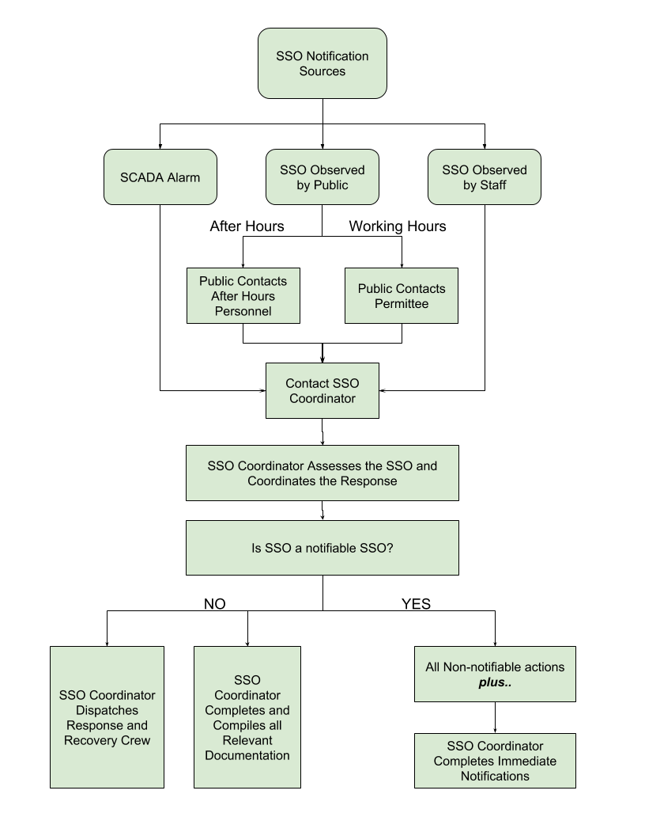

SSO Response Procedures

Customer Relations
As a representative of the System, you will occasionally have to deal with an irate homeowner. A sewer backup is a stressful event and even a reasonable homeowner can become irate if it is perceived that staff members as being indifferent, uncaring, unresponsive, and/or incompetent.
Although sometimes difficult, effective management of a sewage backup situation is critical. If it is not managed well, the situation can end up in a costly, prolonged process with the homeowner. The homeowner should feel assured that the City is responsive, and the homeowner’s best interest is a top priority.
It is important for employees to communicate effectively with customers, especially in sewage backup situations. How we communicate – on the phone, in writing, or in person – is how we are perceived. Good communication with the homeowner results in greater confidence in our ability to address the problem satisfactorily, less chance of having the homeowner prolong the claims process, and less chance of the customer exaggerating the damage done on the property.
Here are a few communication tips:
- Give the homeowner ample time to explain the situation or to vent. Show interest in what the homeowner has to say, no matter how many times you have heard it before, or how well you understand the problem.
- As soon as possible, let the customer know that you will determine if the source of the sewer backup is in the sewer main and, if it is, will have it corrected as quickly as you can.
- Acknowledge the homeowner’s concerns. For example, if the homeowner seems angry or worried about property damage, say something like, “I understand that you’re concerned about the possible damage to your property, but a professional cleanup crew can restore the area.”
- Express understanding and empathy for any inconveniences caused by the incident, but do not admit fault. If it is determined that the System is at fault, the property owner has the right to file a claim for any reasonable repairs or losses resulting from the incident.
- As much as possible, keep the homeowner informed on what is being done and will be done to correct the problem.
- Keep focused on getting the job done in a very professional manner. Don’t wander from the problem with too much unnecessary small talk with the homeowner.
- Don’t find fault or lay blame on anyone.

Responder Priorities
The responder’s priorities are:
- To follow safe work practices.
- To respond promptly with the appropriate equipment.
- To evaluate the cause of spill and determine responsibility.
- To restore the flow as soon as possible.
- To contain the spill whenever feasible.
- To minimize public access to and/or contact with the spilled sewage.
- To update the Primary SSO Coordinator.
  - If the Primary SSO Coordinator cannot be reached, contact the Secondary SSO Coordinator.
- To return the spilled sewage to the sewer system.
- To restore the area to its original condition (or as close as possible) and properly disinfect the area, if possible.

Safety
The responder is responsible for following safety procedures at all times. Special safety precautions must be observed when performing sewer work. Special consideration should be given to following all local traffic, confined space, and safety procedures.

Initial Response
All sewer system calls require a response to the reported location of the event in an attempt to minimize or eliminate an overflow. The responder must respond as soon as feasible after initial notification of the spill.
The responder should determine appropriate response measures based on the circumstances and information provided by the caller (e.g. weather and traffic conditions, small backup vs. sewage flowing on the ground, etc.). If additional help is needed, contact other employees, contractors, and/or equipment suppliers.
Upon arrival at the site, the responder should:
- Note arrival time at spill site.
- Verify the existence of a sewer system spill or backup.
- Field verify the address and nearest cross street, making sure it’s part of the City’s sanitary sewer system.
- Identify and clearly assess the affected area and extent of spill.
- Comply with all safety precautions (traffic, confined space, etc.)
- Contact caller, if time permits.
- Notify the Primary SSO Coordinator if:
  - The spill appears to be large, in a sensitive area, or there is doubt regarding the extent, impact, or how to proceed; or
  - Additional help is needed for line cleaning or repair, containment, recovery, sampling, and/or site cleanup.
- If the Primary SSO Coordinator cannot be reached, contact the Secondary SSO Coordinator.
- It is recommended to document conditions upon arrival with photographs (given that the activity does not interfere with SSO recovery and clean up).

Restore Flow
Upon arrival at the location of a spill into a house or a building, the responder should evaluate and determine if the spill was caused by a blockage in the lateral or in the System-owned sewer main, caused either by a backup in the sewer main line or nearby operation and maintenance (O&M) or construction activities.
- If a blockage is found in a property owner’s lateral that was not cause by the System, it should be clearly communicated that it is not the System’s responsibility to work on a private lateral. Recommend that property owner or tenant contact a qualified plumbing contractor to remove the blockage.
- If a blockage is found in a property owner’s lateral that was caused by the System, insert information on how your system handles problems on private property where the system is at fault here.
- If a backup in the main line is found to have caused the SSO in a house or building, relieve the blockage in the main line.
The responder should attempt to remove the blockage from the system and restore flow to the area. Using the appropriate cleaning tools, the field crew should set up downstream of the blockage and hydro-clean upstream from a clear maintenance hole. The flows should be observed to ensure that the blockage does not recur downstream.
If the blockage cannot be cleared within a reasonable time, or sewer requires construction repairs to restore flow, then initiate containment and/or bypass pumping. If assistance is required, immediately contact other employees, contractors, and equipment suppliers.

Pump Station or Forcemain Facilities
The responder to a potential pump station or forcemain failure should:
- Determine whether flow can be restored within a reasonable time.
- If it appears that flow cannot be restored within a reasonable time or if the conveyance system facility requires construction and/or repairs, then employ contingency plans covering containment, bypass pumping, portable electric generators, contractual assistance, etc.
If assistance is required, immediately contact other employees, contractors, and equipment suppliers as required.

Contain the Spill
The responder should attempt to contain as much of the spilled sewage as possible using the following steps:
- Determine the immediate destination of the overflowing sewage.
- Plug storm drains using available equipment and materials to contain the spill, whenever appropriate. If spilled sewage has made contact with the storm drainage system, attempt to contain the spilled sewage by plugging downstream storm drainage facilities.
- Contain/direct the spilled sewage using dike/dam, sandbags, or other containment materials on hand.
- Pump around the blockage/pipe failure/pump station or vacuum flow from upstream of the blockage and dispose of downstream of the blockage to prevent further overflow.
- When an SSO occurs inside of a house or building, the property owner should be instructed to follow these guidelines:
  - Keep people and pets away from the affected area.
  - Place towels, rags, blankets, etc. between areas that have been affected and areas that have
not been affected.
  - Do not remove any contaminated items
  - Turn off the HVAC system
  - Move any uncontaminated property away from the overflow area.
- NOTE: If an SSO reaches a water body, see Recovery and Clean Up Section for Water Quality Sampling requirements.

SSO Public Notification and Restricted Public Access
Barriers shall be installed to prevent the public from having contact with the sewage if possible. Signs should be posted at the spill to keep vehicles and pedestrians away from contact with spilled sewage. Do not remove the signs until directed by the County Health Department or until the threat for human contact has ceased. A sample warning sign is included as Appendix A. (Note: This section is provided as an example. The feasible methods of public notification should be included in the specific utility SOP.)

Recovery and Clean Up
The recovery and clean up phase begins when the flow has been restored and the spilled sewage has been contained to the extent possible.

Recovery of Spilled Sewage
Vacuum up or pump the spilled sewage and discharge it back into the sanitary sewer system.

Clean Up and Disinfection
Clean up and disinfection procedures should be implemented to reduce the potential for human health issues and adverse environmental impacts that are associated with an SSO event. The procedures described are for dry weather conditions and should be modified as required for wet weather conditions.
Where clean up is required inside a private property (e.g. back up into house), the Primary SSO Coordinator will arrange for an outside contractor to perform clean up.

Private Properties
Spills inside houses or buildings should be cleaned up by a professional cleaning company. Insert information on how your system will handle / process claims.

Hard Surface Areas
Collect all signs of sewage solids and sewage-related material with the use of rakes and brooms.
- Take reasonable steps to contain and vacuum up the wastewater.
- Disinfect all areas that were contaminated from the overflow using the disinfectant solution of household bleach diluted 10:1 with water. Apply minimal amounts of the disinfectant solution using a hand sprayer. Disinfectant should be applied in such a manner as to prevent runoff. Document the volume and application method of disinfectant that was employed.
- Allow area to dry. Repeat the process if additional cleaning is required.

Landscaped and Unimproved Natural Vegetation
- Collect all signs of sewage solids and sewage-related material either by hand or with the use of rakes and brooms.
- Allow the area to dry. Repeat the process if additional cleaning is required.

Natural Waterways
Clean up should proceed quickly in order to minimize SSO impacts to any creeks, gullies, or natural waterways. Any water that is used in the cleanup process should be de-chlorinated prior to use.

Wet Weather Modifications
Omit water quality sampling during heavy storm events with heavy runoff where water quality sampling would not provide meaningful results.

Water Quality Sampling Procedures
(NOTE: Identification of a contractor who will collect and analyze the sample(s) may be listed in lieu of the procedures.)
If your system conducts water quality sampling during and/or after a SSO event, list the steps for conducting those samples below.
An example might look like the following:
- The responder should notify the System’s Laboratory Technicians to collect samples. Samples should be collected as soon as possible after the discovery of the SSO event.
- At a minimum, water quality samples should be collected at the discharge point, 100 feet upstream, and 100 feet downstream.
- If a spill reaches a large water body, the water quality samples should be collected near the point of entry of the spilled sewage and every 100 feet along the shore of stationary water bodies or as directed by the County Health Department (CHD).
Include details about the following:
- proper methodology for collecting samples
- materials needed to collect samples
- sample locations (provide GPS locations)
- sample collection procedures
- laboratory information
- alternative laboratory information
- documentation / reporting processes

Contract Laboratory Contact Information
Laboratory | Primary Lab Contact | Primary Phone | Alternate Phone | Email
(example) | Dr. John Smith |  |  | chemist@lab1.com
Primary Lab
Alternate Lab
Others

Estimate the Volume of Spilled Sewage
Use the methods outlined in Appendix C to estimate the volume of the spilled sewage. Wherever possible, document the estimate using photos of the SSO site before and during the recovery operation.

Follow Up Activities
If sewage has reached the storm drain system, the combination sewer jet vacuum cleaning truck should be used to vacuum/pump out the catch basin and any other portion of the storm drain that may contain sewage.
In the event that an overflow occurs at night, the location should be re-inspected first thing the following day. The operator should look for any signs of sewage solids and sewage-related material that may warrant additional cleanup activities.

SSO Event Debriefings
These SSO events provide opportunities to evaluate response and reporting procedures. After these SSO events, all of the participants, from the person who received the call to the last person to leave the site, may meet to review the procedures used and to discuss what worked and where improvements could be made in responding to and mitigating future SSO events. The results of SSO event debriefings will be recorded and tracked to ensure the action items are completed.

Claims for Backups into a Building
Insert details about how your system handles backups into a customer’s building here.

Public and County Health Department Notification

County Health Department Notification Requirements
The SSO Responder shall contact the local County Health Department (CHD) within 24-hours of the Permittee becoming aware of the SSO.
- Local CHD Primary Telephone Number:
- Local CHD Primary Fax Number:
- Local CHD Primary Email Address:
- Local CHD Environmental Services Telephone Number:
- Local CHD Environmental Services Fax Number:
- Local CHD Environmental Services Email Address:

Contact information for all counties with portions of the collection system or that may receive discharge from an SSO should be included.

Public Notification Requirements
(The Permittee shall make a determination concerning which methods of Public Notification are feasible for the Permittee and list them here. An example might look like the following:)
Feasible Methods of Public Notification Available
Choose from below noted feasible methods and add any other additional feasible methods.
- Preprinted Methods of Public Notification indicating an SSO has occurred
  - Flyers
  - Warning Signs
  - Door Hangers
- Website and/or social media
  - Minimum information in the notification shall include information to be added by Permittee
- Local print or radio and broadcast media (Add name and contact information for local media)
  - Minimum information in the notification shall include information to be added by Permittee
- “opt in” email, text messages, or automated phone messages (Add methods for the public to register)
  - Minimum information in the notification shall include information to be added by Permittee
(For each method deemed feasible by the Permittee, steps to produce and acquire materials (e.g. location of preprinted materials), as well as instructions for usage of notification methods, and contact information of service and media outlets should be provided.)

Required Information to Include in Public Notifications
Minimum information to be included in public notifications (e.g., identification that an SSO has occurred, date, duration if known, estimated volume if known, location of the SSO by street address or other appropriate method, initial destination of the SSO).

Procedures for Determining the Appropriate Method(s) of Public Notification
Procedures for determining the appropriate public notification method(s) based upon the potential for public exposure to health risks associated with the SSO should be included below. (An example might look like the following:)
Scenario 1: A spill occurs at a remote lift station. The spill is bad enough that waste escapes the enclosed area but does not reach a surface water.
Public Health Risk: Low
Public Notification Method(s):
- Deploy signage around the spill.
Scenario 2: A major spill occurs during dry weather near a local swimming and recreational area. The spill enters the waterbody.
Public Health Risk: Very High
Public Notification Method(s):
- Contact local authorities and CHD to discuss closure of the public recreation area.
- Deploy signage at locations where contact with public may occur.
- Contact surrounding public water system officials about the spill if PWS downstream of spill.
- Issue text and email alerts.
- Provide press release to local radio and television media.
- Publish press release to website
An example warning sign is included in Appendix A of this template.

Point of Contact
The SSO Coordinator shall be responsible for public notification via the media and other affected entities (such as public water systems), if necessary.

SSO Documentation and Reporting
All SSOs should be thoroughly investigated and documented for use in managing the sewer system and meeting established reporting requirements.

Internal SSO Documentation
(Insert your Internal Documentation Guidance here. The following is presented as a simple example.)
The Primary SSO Coordinator, or their designee, will prepare a file for each individual SSO. The file should include the following information:
- Initial service call information
- Checklist for Plugged Sewer Line and Checklist Form (Appendix D)
- Copies of the E2-SSO Forms (if printed)
- Volume estimation, including method and calculations
- Photographs, if applicable
- Water quality sampling and test results, if applicable

External SSO Documentation
The SSO Responder shall submit a notification to the Alabama Department of Environmental Management (ADEM) within 24-hours of the Permittee becoming aware of the SSO. The SSO Responder shall submit the follow-up report within 5 days of the Permittee becoming aware of the SSO.
All publicly or privately owned wastewater treatment plants holding an NPDES permit are required to provide immediate notification to ADEM, county public health officials, the public, and any other affected entity such as public water systems as soon as possible upon becoming aware of any notifiable sanitary sewer overflow (SSO) events.
A “notifiable SSO", as defined in ADEM Admin. Code r. 335-6-6-.02(hh), is an overflow, spill, release or diversion of wastewater from a sanitary sewer system that either (1) reaches a surface water of the State or (2) may imminently and substantially endanger human health based on potential for public exposure including but not limited to close proximity to public or private water supply wells or in areas where human contact would be likely to occur. Immediate notification shall be provided within 24 hours of becoming aware of the event. This immediate notification must be made electronically through the Department's eSSO Electronic Reporting System. The follow-up report shall be submitted within five days of becoming aware of the SSO event using the Department's eSSO Electronic Reporting System. If the Permittee is not registered for the Department’s eSSO Electronic Reporting System, the immediate notification may be made verbally to the Department's SSO Hotline at (334) 274-4200 and the follow-up report may be submitted using ADEM Form 415. However, the Department’s eSSO Electronic Reporting System and the SSO Hotline/ADEM Form 415 should not BOTH be utilized to report. Please be aware that the eSSO Electronic Reporting System is replacing the SSO Hotline and hard copy ADEM Form 415. Registration information for the Department’s eSSO system can be found at the following link: (https://e2.adem.alabama.gov/NPDES).
For notifiable SSOs caused by an extreme weather event (e.g., hurricane) that floods the entire sewer system and are too numerous to count, the permittee is not required to provide information that cannot be practicably captured (e.g. latitude/longitude, source/structure, duration of the SSO, the estimated discharge volume, the receiving waterbody, the corrective actions taken, or the potential impacts).

Equipment Inventory
(Build out your equipment inventory list in this table. Attach additional sheets if necessary.)
Equipment  ID | Equipment  Name | Equipment Description | Equipment  Location
(example) Jetter1 | “The Big Flush” | Trailer mounted Sewer Jetting Unit. | Sanitation Shop #1

Appendix A

Example Warning Signs


KEEP OUT

CONTAMINATED WATER

STREAM/LAKE WATER
MAY
CAUSE ILLNESS

BY ORDER OF THE HEALTH OFFICER
COUNTY HEALTH DEPARTMENT
FOR FURTHER INFORMATION
CALL: (555) 555-5555
OR CALL
ANYTOWN WASTEWATER SYSTEM
(555) 555-5555
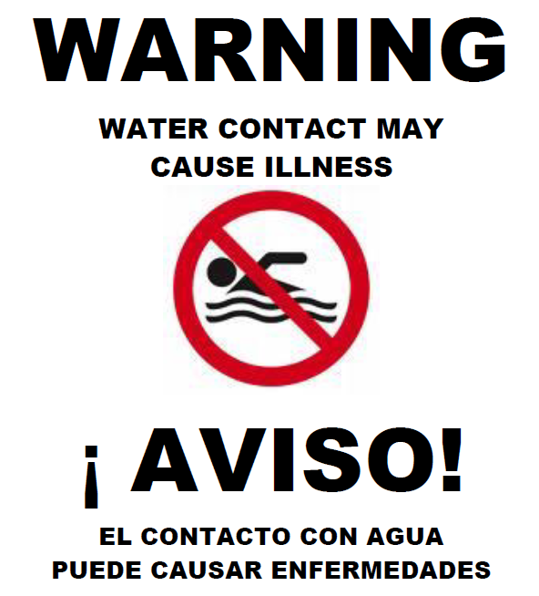
BY ORDER OF THE HEALTH OFFICER
COUNTY HEALTH DEPARTMENT
FOR FURTHER INFORMATION
CALL: (555) 555-5555
OR CALL
ANYTOWN WASTEWATER SYSTEM
(555) 555-5555

Appendix B

Checklist for Plugged Sewer Line and Overflow Form

Example Checklist for Plugged Sewer Line
Date:
Time Notified: am / pm
By Whom: Caller’s Phone #
Time Start: am / pm Time Finish: am / pm
After Hours Callout: Y N Work Day: Y N
Call In: Y N
- Problem location of address:

- System main line checked:
  - PROPERTY OWNER’S RESPONSIBILITY Y N
- System line plugged: Y N
  - Set up at manhole number
Footage to obstruction
  - Description of Plug: GREASE ROOTS
BROKEN PIPE RAGS
OTHER
- Cleared Line and Advised Reporting Party: Y N
- PROPERTY DAMAGE REPORTED BY RESIDENT? Y* N
- SANITARY SEWER OVERFLOW OR SPILL Y* N
- Upstream manhole verified clear: Y N
- Upstream manhole and overflow area cleaned: Y N
Comments:

* Sanitary Sewer Overflow or Spill and/or Property damage reported: Immediately contact Supervisor, Public Works Manager, Public Works Director or Wastewater Treatment Manager.
Example Internal Overflow Form

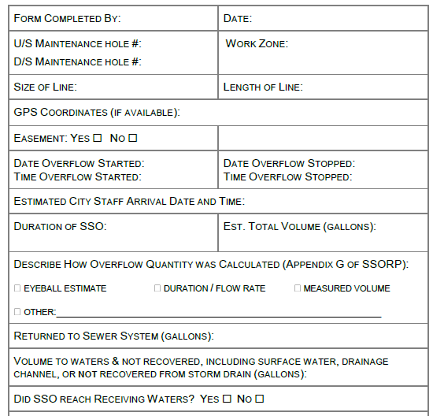
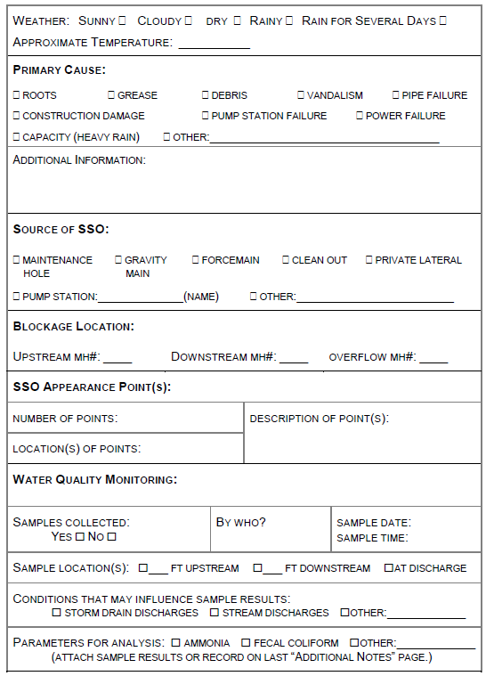
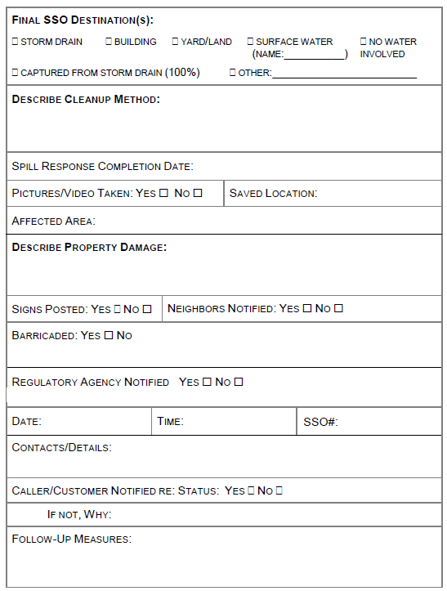
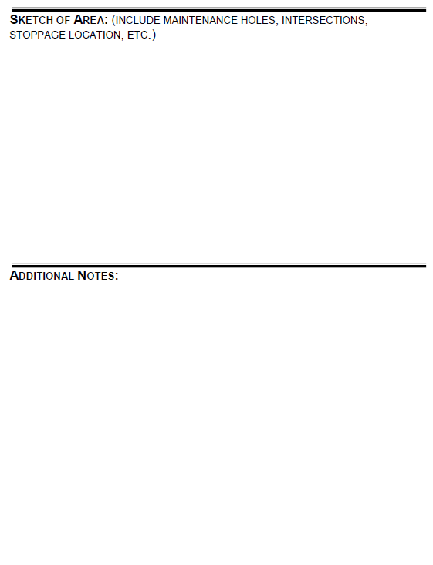

Appendix C
Methods for Estimating Spill Volume

Methods for Estimating Spill Volume
A variety of approaches exist for estimating the volume of a sanitary sewer spill. This appendix documents the three methods that are most often employed. The person preparing the estimate should use the method most appropriate to the sewer overflow in question and use the best information available. Photographs are critical in using any of the spill volume methods.

Method 1 Eyeball Estimate
The volume of small spills can be estimated using an “eyeball estimate”. To use this method, imagine the amount of water that would spill from a bucket or a barrel. A bucket contains 5 gallons and a barrel contains 50 gallons. If the spill is larger than 50 gallons, try to break the standing water into barrels and then multiply by 50 gallons. This method is useful for contained spills up to approximately 200 gallons.

Method 2 Area/Volume Calculations
The volume of most small spills that have been contained can be estimated using this method. The shape, dimensions, and the depth of the contained wastewater are needed. The shape and dimensions are used to calculate the area of the spills and the depth is used to calculate the volume.
- Step 1 Sketch the shape of the contained sewage (see Figure 1).
- Step 2 Measure or pace off the dimensions.
- Step 3 Measure the depth at several locations and select an average.
- Step 4 Convert the dimensions, including depth, to feet.
- Step 5 Calculate the area in square feet using the following formulas:
  - Rectangle: Area = length (feet) x width (feet)
  - Circle: Area = diameter (feet) x diameter (feet) x .785
  - Triangle: Area = base (feet) x height (feet) x 0.5
- Step 6 Multiply the area (square feet) times the depth (in feet) to obtain the volume in cubic feet.
- Step 7 Multiply the volume in cubic feet by 7.5 to convert it to gallons
Figure 1: Common Shapes and Dimensions


Method 3 Duration and Flowrate
Calculating the volume of larger spills, where it is difficult or impossible to measure the area and depth, requires a different approach. In this method, the separate estimates are made of the duration of the spill and the flowrate. The methods of estimating duration and flowrate are:
Duration: The duration is the elapsed time from the time the spill started to the time that the flow was restored.
Start time: The start time is sometimes difficult to establish. Here are some approaches:
- Local residents can be used to establish start time. Inquire as to their observations. Spills that occur in rights-of-way are usually observed and reported promptly. Spills that occur out of the public view can go on longer. Sometimes observations like odors or sounds (e.g. water running in a normally dry creek bed) can be used to estimate the start time.
- Changes in flow on a downstream flowmeter can be used to establish the start time. Typically, the daily flow peaks are “cut off” or flattened by the loss of flow. This can be identified by comparing hourly flow data during the spill event with flow data from prior days.
- Conditions at the spill site change over time. Initially there will be limited deposits of toilet paper and other sewage solids. After a few days to a week, the sewage solids form a light-colored residue. After a few weeks to a month, the sewage solids turn dark. The quantity of toilet paper and other materials of sewage origin increase over time. These observations can be used to estimate the start time in the absence of other information. Taking photographs to document the observations can be helpful if questions arise later in the process.
- It is important to remember that spills may not be continuous. Blockages are not usually complete (some flow continues). In this case the spill would occur during the peak flow periods (typically 10:00 to 12:00 and 13:00 to 16:00 each day). Spills that occur due to peak flows in excess of capacity will occur only during, and for a short period after, heavy rainfall.
End time: The end time is usually much easier to establish. Field crews on-site observe the “blow down” that occurs when the blockage has been removed. The “blow down” can also be observed in downstream flowmeters.
Flow Rate: The flowrate is the average flow that left the sewer system during the time of the spill. There are three common ways to estimate the flowrate:
The Manhole Flowrate Chart: This chart, attached as Page 4, shows sewage flowing from manhole covers at a variety of flowrates. The observations of the field crew can be used to select the appropriate flowrate from the chart. If possible, photographs are useful in documenting basis for the flowrate estimate.
- Flowmeter: Changes in flows in downstream flowmeters can be used to estimate the flowrate during the spill.
- Counting Connections: Once the location of the spill is known, the number of upstream connections can be determined from the sewer maps. Multiply the number of connections by 200 to 250 gallons per day per connection or 8 to 10 gallons per hour per connection.

For example: 22 upstream connections x 9 gallons per hour per connection
= 198 gallons per hour / 60 minutes per hour
= 3.3 gallons per minute

Spill Volume: Once duration and flowrate have been estimated, the volume of the spill is the product of the duration in hours or days and the flowrate in gallons per hour or gallons per day.
For example:
Spill start time = 11:00
Spill end time = 14:00
Spill duration = 3 hours
3.3 gallons per minute X 3 hours X 60 minutes per hour = 594 gallons
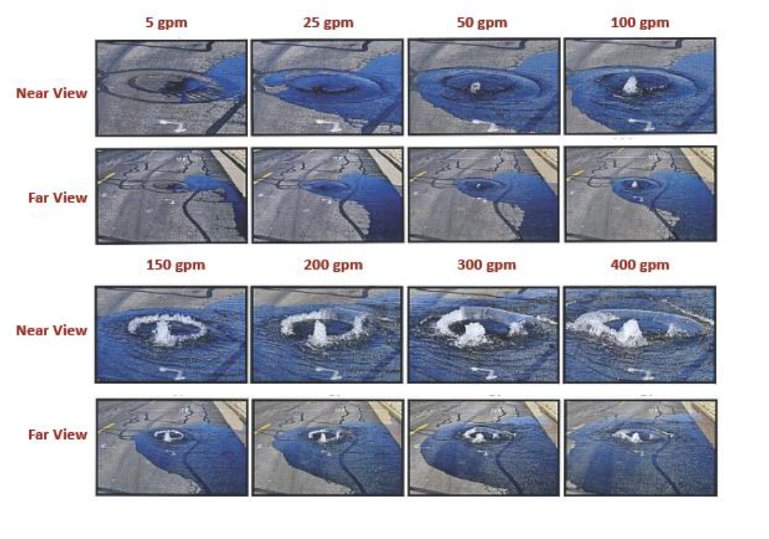

Pro Tip - A free and useful tool for building flowcharts can be found at https://docs.google.com/drawings
The language found in this section is included by the Alabama Rural Water Association for the purposes of providing an example only. The example presented is not explicitly required by the Permit; however, ADEM has provided some suggestions for this section. The system completing this template should provide language suited to its own policies.
The language found in this section is included by the Alabama Rural Water Association for the purposes of providing an example only. The example presented is not explicitly required by the Permit; however, the Department has provided some suggestions for this section. The system completing this template should provide language suited to its own policies.
If reporting Party is not at home, fill out door hanger information card and leave on reporting party’s front door.

